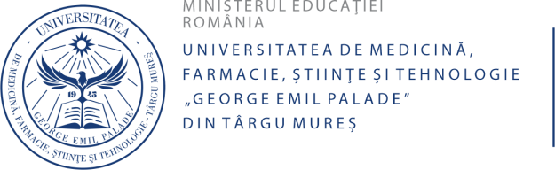

FACULTATEA DE FARM ACIE



CURRICULUM VITAE

Date personale
Nume, prenume: Ana-Maria Cucoș
Email instituțional: 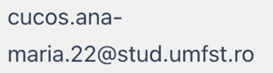
Titlu academic: Drd. MSc.
Disciplină, departament: Informatică / UMFST G.E. Palade Târgu Mureș
Domeniul profesional de activitate
Specialitate/supraspecializări:
Computer Science, Artificial Intelligence, Machine Learning, Cheminformatics, Drug Discovery, Computer Graphics, Adverse Drug Reaction Prediction, Molecular Descriptors, Chemical Fingerprints

Activitate de cercetare
Teme și direcții de cercetare (max. 3 direcții):
- Artificial intelligence-driven prediction of adverse drug reactions using chemical fingerprints and molecular descriptors​
- Machine learning applications in drug discovery and cheminformatics, including drug-drug interaction prediction
- Computer graphics and visualization techniques for pharmaceutical and bioinformatics applications​

Lucrări publicate în extenso (max. 5 lucrări reprezentative):
- Cucoș, Ana-Maria. (2024). "Artificial Intelligence-Driven Prediction of Adverse Drug Reaction: Exploring the Role of Chemical Fingerprints and Molecular Descriptors." Presented at International Conference of PhD Students and Young Doctors, UMFST G.E. Palade, Târgu Mureș​

